This guide aims to show how to declare a sidechain using the sphere by Horizen wallet and then proceed to a transaction between the mainchain and the previously created sidechain.

**Installation Sphere by Horizen**

To start, you need to get the testnet version of the Sphere by Horizen wallet here :

<https://github.com/HorizenOfficial/Sphere_by_Horizen_Sidechain_Testnet/releases/tag/desktop-v2.0.0-beta-sidechain-testnet>

I use the Windows operating system, so I download the installation file for this system.

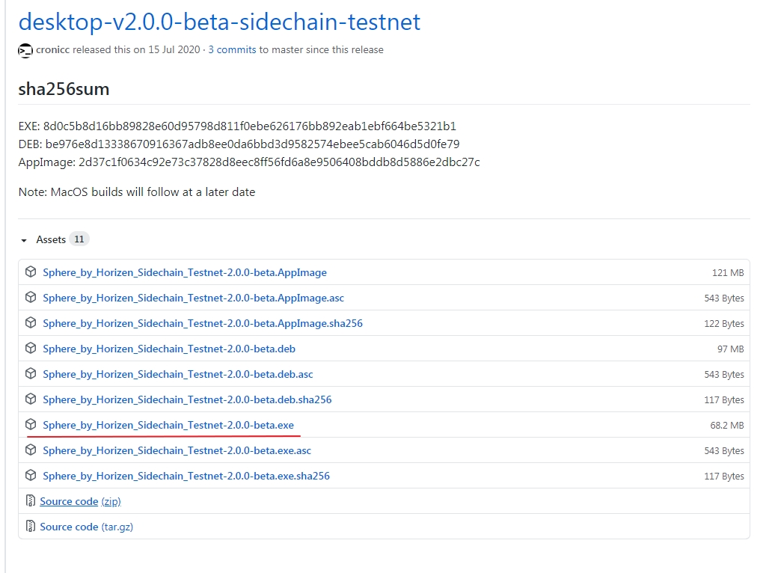

After the installation is complete, you will see the main screen of your wallet. Create a new account.

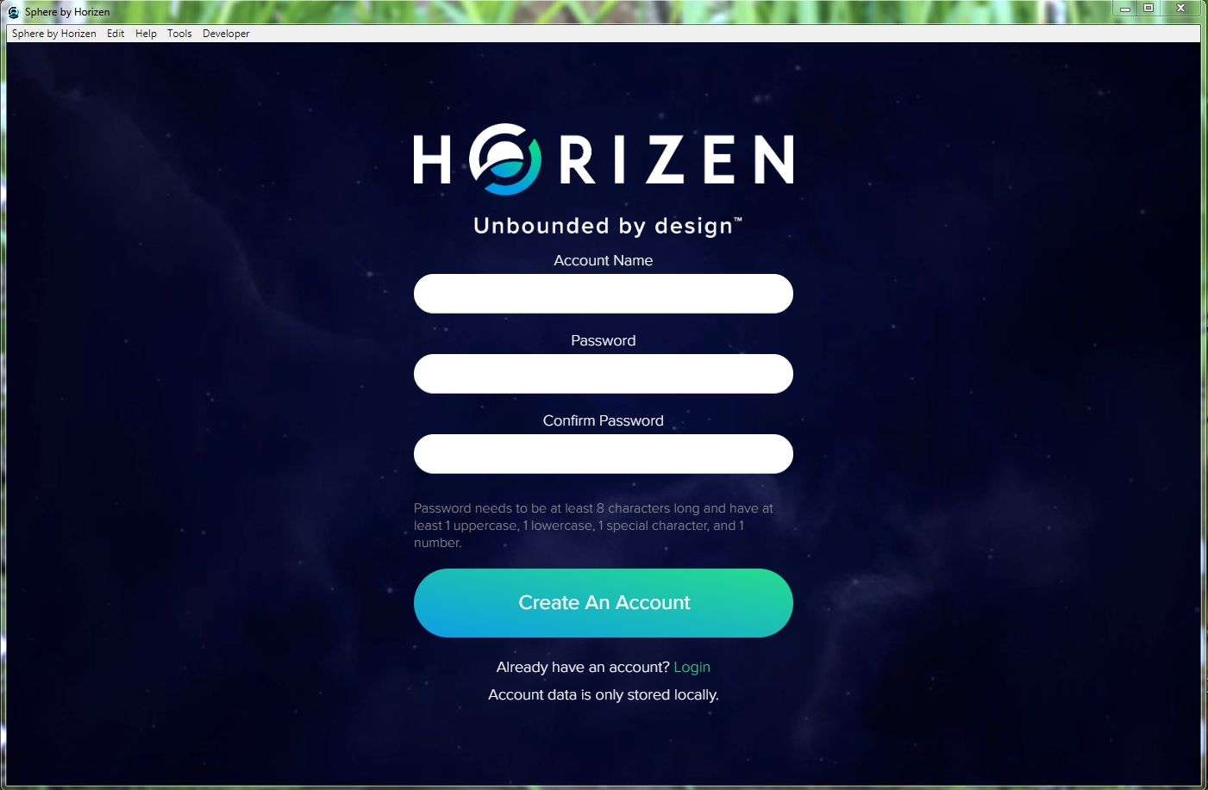

After creating an account, log in to your wallet and wait for the connection to the blockchain.

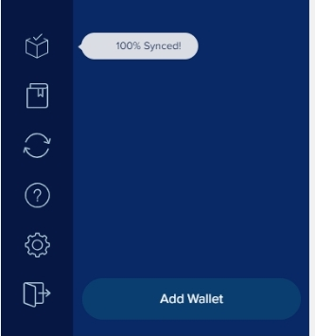

After connecting to the blockchain, create a new wallet using the "Add Wallet" button. You don't have to write down secret phrases, they won't be useful to you.

After creating a wallet, you need to get a dummy Zen. To do this, you will need your wallet address.

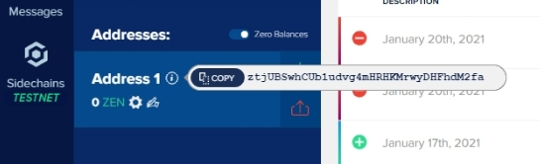

To get the dummy zen we go to the following address <https://heap.horizen.io/>

Enter the wallet address you just created to get your dummy ZEN !

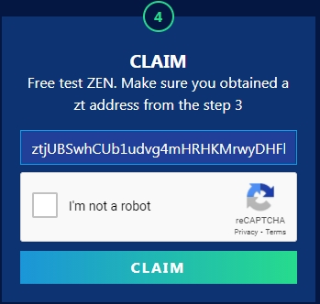

Enter your wallet address in the field as shown above in the image and click Claim.

Now we need to wait for our Zen to arrive to our wallet. This may take some time.

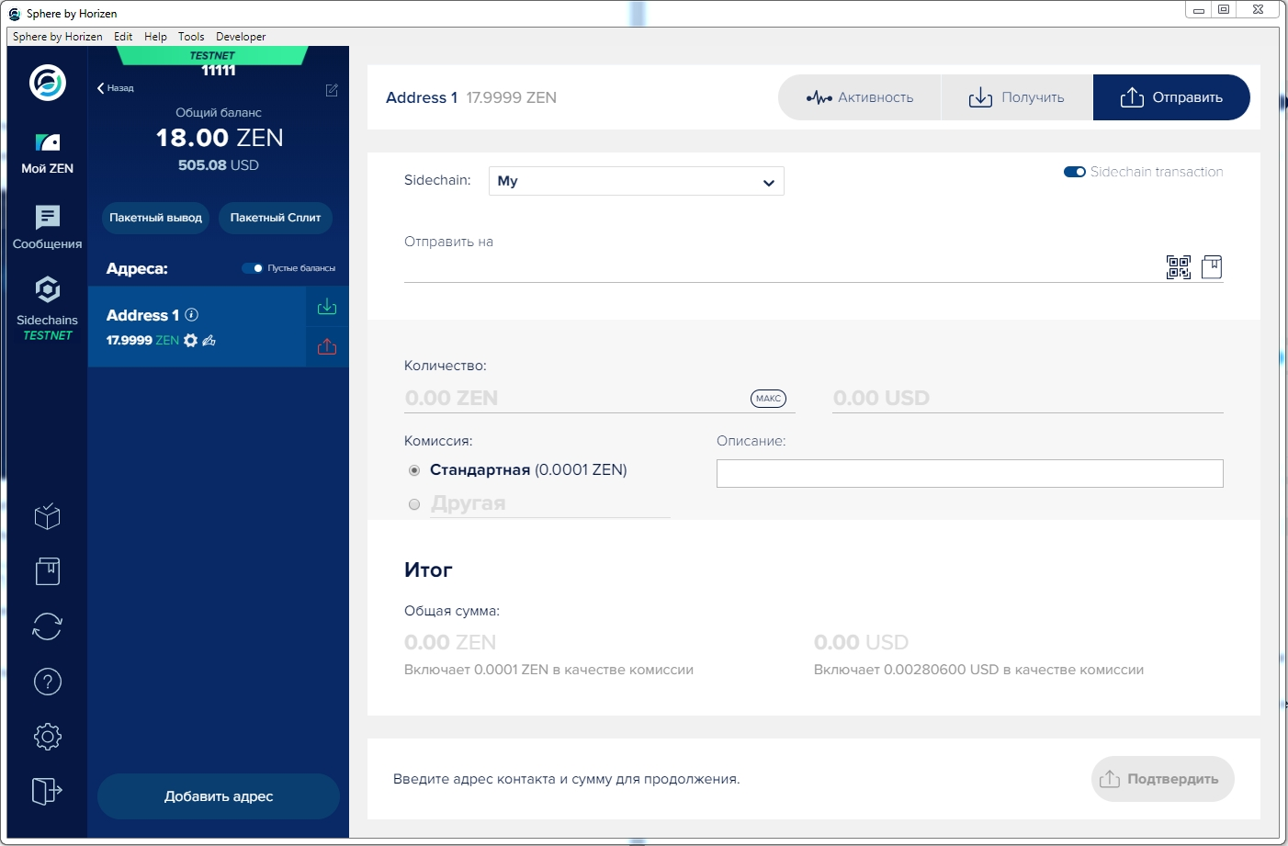

And so we got our Zen and can move on to the next part of the task.

For the next step, we need to install the following programs.

These softwares:

**Java 8.0 version or higher** [**https://java.com/tr/download/**](https://java.com/tr/download/)

**Maven**  [**https://maven.apache.org/download.cgi**](https://maven.apache.org/download.cgi)

**Scala**  [**https://www.scala-lang.org/download/**](https://www.scala-lang.org/download/)

After we have installed all the necessary programs, we move on.

I start by retrieving the Sidechains-SDK, I place myself in the directory thus created and I start the compilation :

**$ git clone** [**https://github.com/ZencashOfficial/Sidechains-SDK.git**](https://github.com/ZencashOfficial/Sidechains-SDK.git)

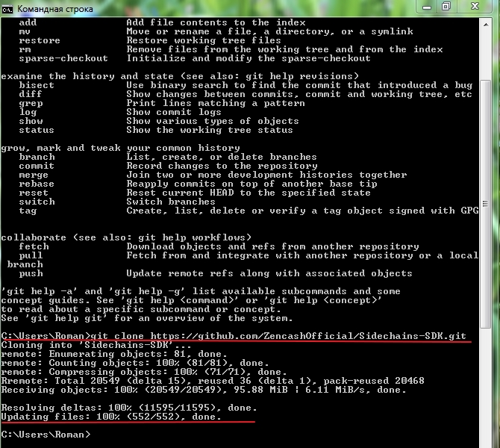

Then I move to the directory created above.

**$ cd Sidechains-SDK**

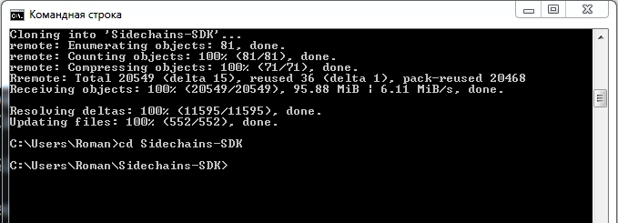

Finally, I use **Maven** to compile.

$ **mvn package**

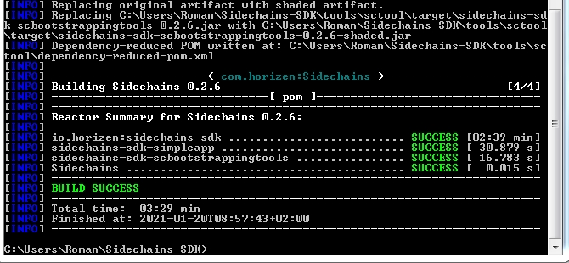

## **Bootstrapping**

For this process I followed the steps listed here <https://github.com/HorizenOfficial/Sidechains-SDK/blob/master/examples/simpleapp/README.md>

Below at each step the screen I got.

java -jar tools/sctool/target/sidechains-sdk-scbootstrappingtools-0.2.5.jar

In the continuation of this process

$ **generatekey {"seed":"my seed"}**

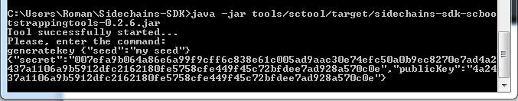

$ **generateVrfKey {"seed":"my seed"}**

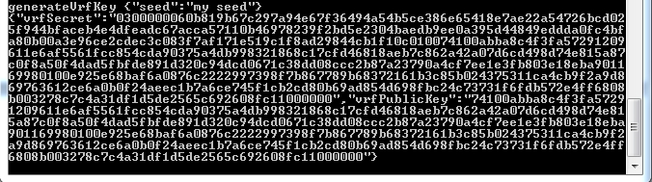

$ **generateProofInfo {"seed":"my seed", "keyCount":7, "threshold":5}**

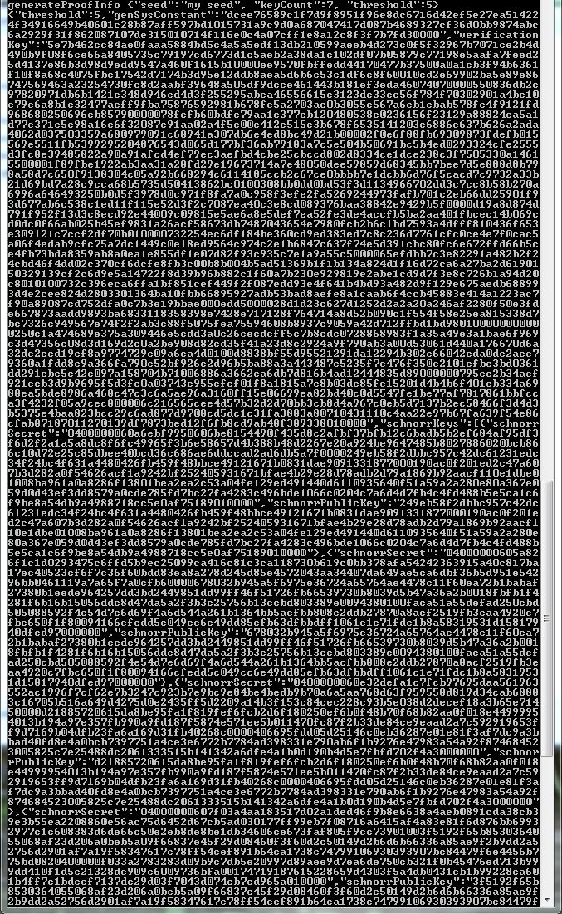

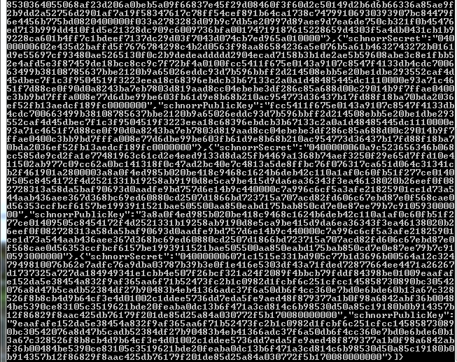

**Warning!!!** Under no circumstances should you close the command prompt before proceeding to the next step. We will need these generated keys.

**Creating a new Sidechain**

Before this transaction, we must have ZEN in our wallet. Because we need to transfer some of these ZENs to our side chain to create a side chain.

In order to create a new side chain, you must be synchronized with the blockchain.

After the connection is established go to the Sidechain TESTNET tab and press the Create new sidechain key.

In the "Pay from" field, we vibrate our wallet.

In the "Amount" field, select the number of Zen.

In the "Custom name" field, we give the name of our side chain.

Now is the time to use the keys we got on the command line.

**Sidechain creation adress**: $ generatekey {"seed":"my seed"} our public key that comes with connotation. Must consist of 64 characters.

**wCertVk**: $ generateProofInfo {"seed":"my seed", "keyCount":7, "threshold":5} verification key with association. Must consist of 3088 characters

**Constant data**: $ generateProofInfo {"seed":"my seed", "keyCount":7, "threshold":5} coming with connotation {"threshold": 5, "geniSys Constant": ……. Our key written in the section. Must consist of 192 characters

**Custom data**: $ generateVrfKey {"seed":"my seed"} vrf public key with connotation. Must consist of 386 characters

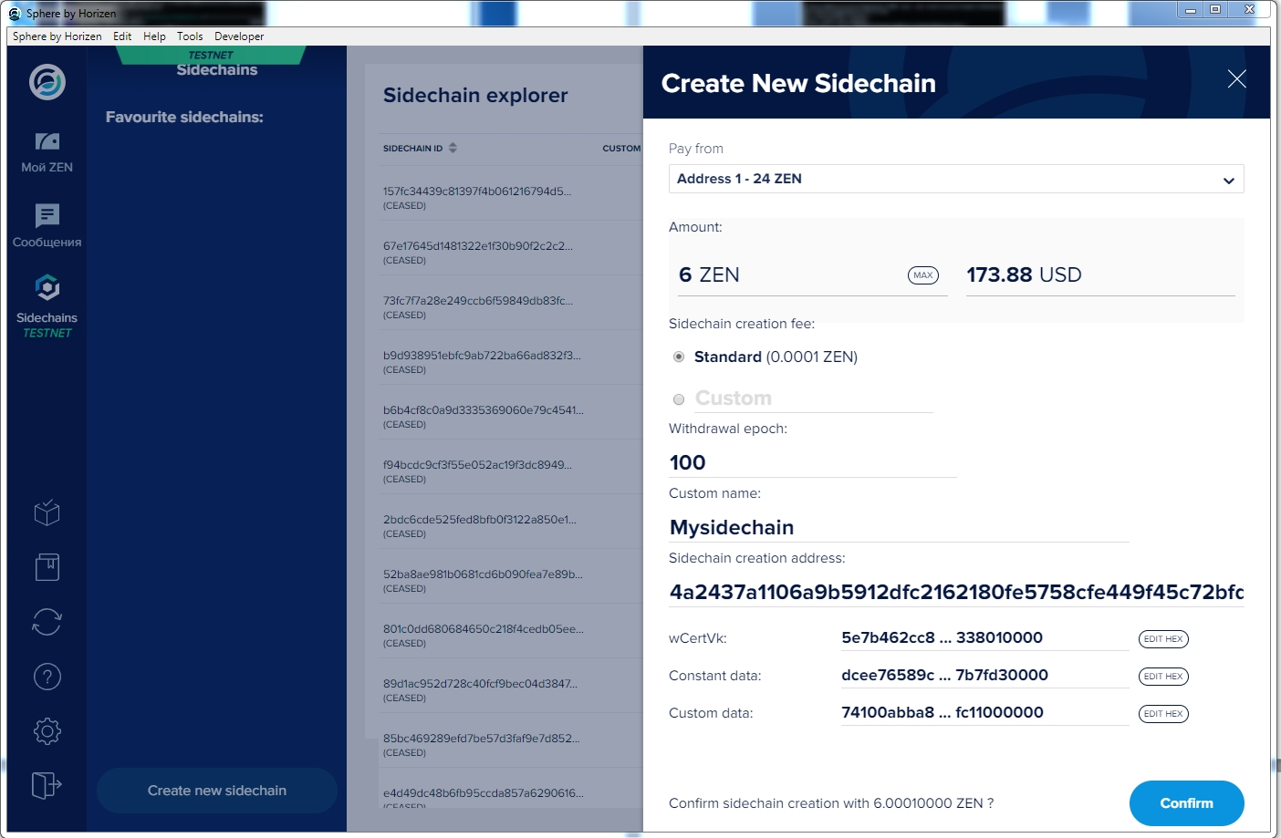

When you have entered all the data click the "Confirm" button.

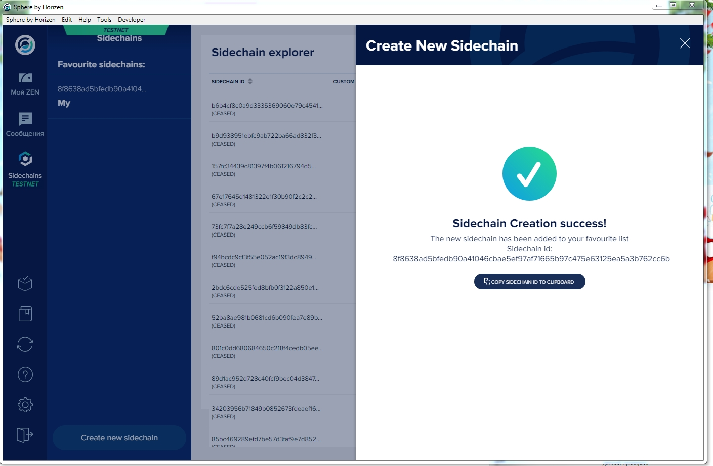

The sidechain is therefore created, it will have to wait for a certain number of confirmations from the network for it to finally be active.

**Trading from the main chain to the side chain**

We enter our wallet and click the "SEND" button on the top right.



We activate the "Side Chain transaction" button at the top right of the screen.

We choose the side chain we created from the sidechain part.

In the Address section, we enter our public key that comes with our $ generate key {"seed": "by seed"} call.

By pressing the Continue button, we are sending to our side chain.

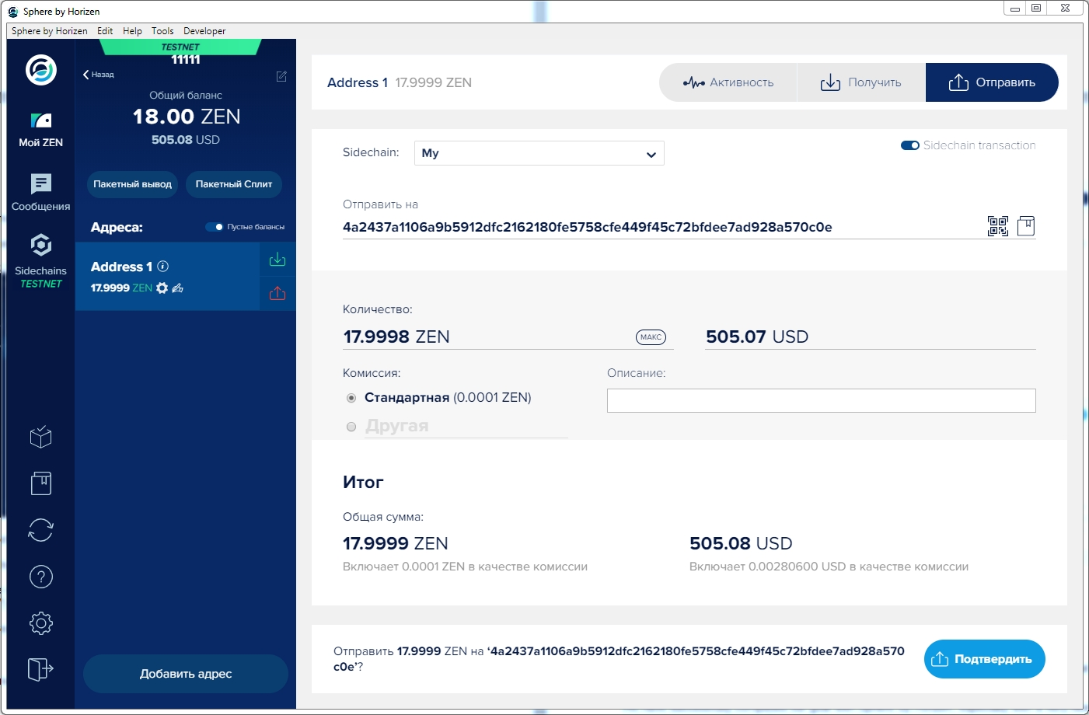

Our transaction will take place after a while.

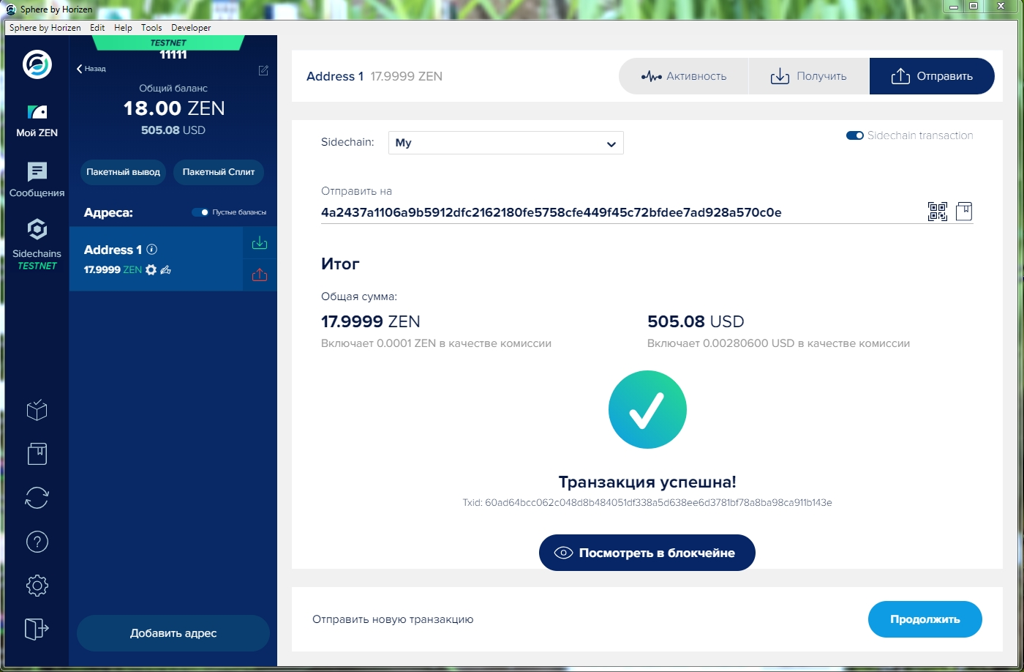

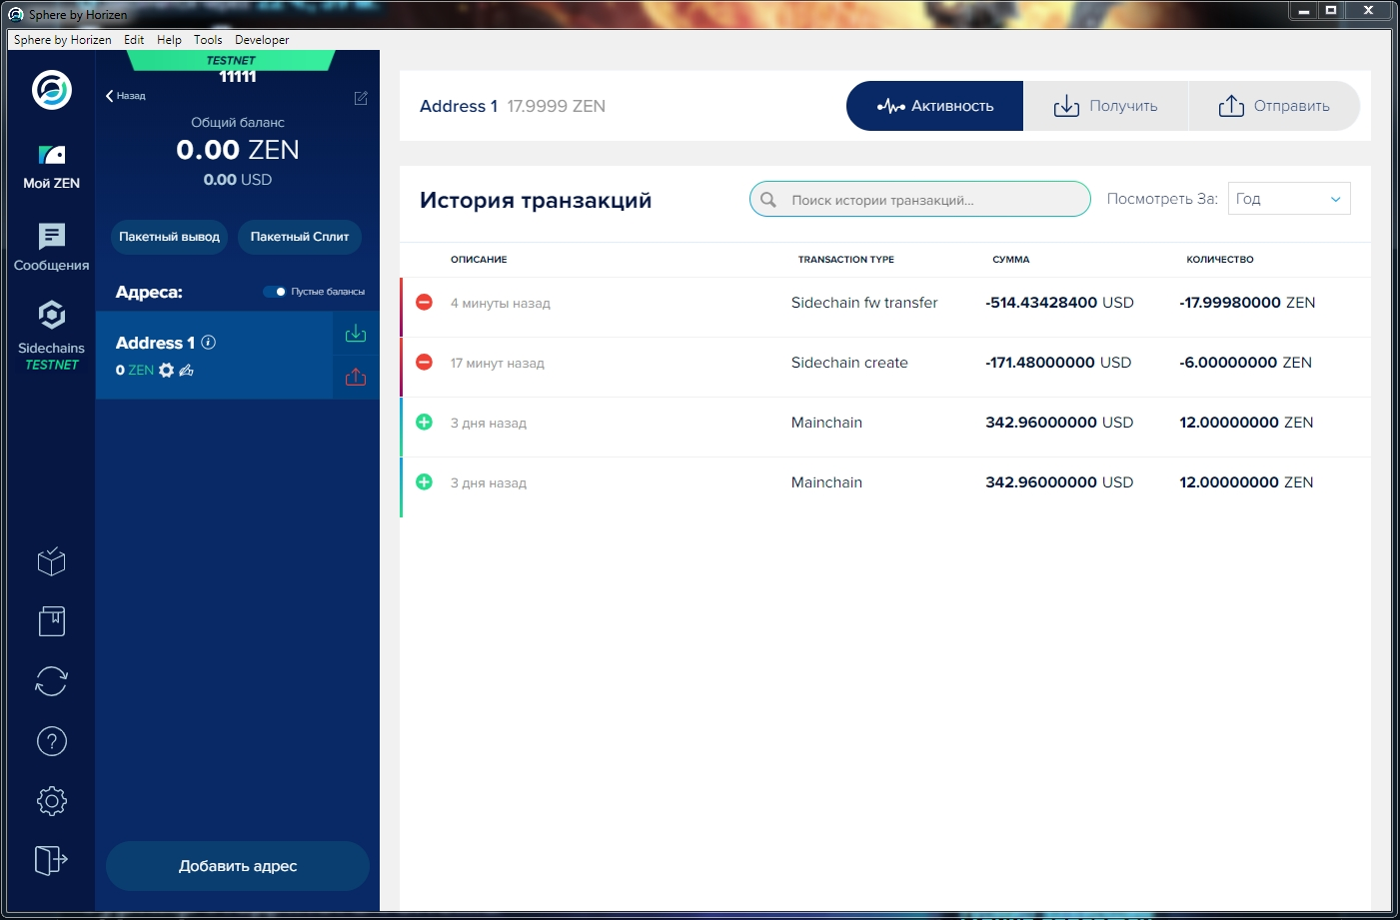

With Sphere by Horizon, we realized our transaction from main chain to side chain with great pleasure.